Documentation of Custom Items/Widgets

In this document you will find information on the two custom item files I, Nia Dicks, was working on during the Summer of 2024. These custom items were created in hopes of giving customers the ability to drag and drop items from the dashboard designer into their own dashboard (similar use to the original key performance indicators KPIs in the older WinForm version of JEE). Inside these files you will find comments mentioning any important things I did. These comments are brief and short - for more in depth explanation of each custom item and its file continue reading. It is key to note that the structure of these files is essentially the same as other custom items created in JEE currently. Furthermore, you will find an explanation for how each file was created, how they function, and the pros and cons of creating a custom item/widget versus creating a standard dashboard.

*\*\*Data Sources: The following data for each custom item/widget was from retrieved from JVIEW_Estimate and JVIEW_EstimateItems*

## Widget-Open-Estimates-Grid

This custom item/widget populates a grid showing information about open estimates in the current users database. This grid populates eight columns: Estimate Number, Customer Name, Create Date, Expected Order Date, Sales Agent, Probability, Probability Price, and Total Price - any of which can be removed using the column chooser in the tool bar. Searching and filtering is available for all columns as well.

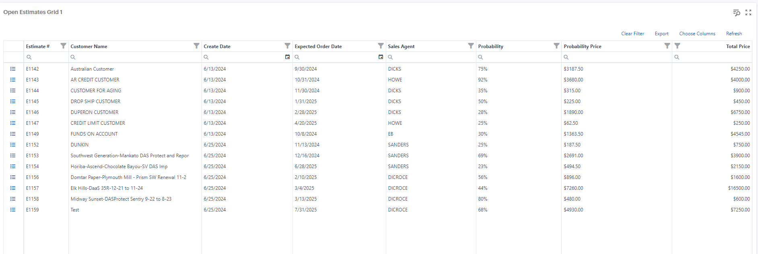

Along the left side of the grid there is a custom button that drills down into an estimate. Each details button corresponds to an estimate – when clicked the associated estimate items appear in a popup grid. This popup grid has the following columns: Item Number, Part Number, Part Revision, PSM, Quantity, Unit of Measure, Material Category, Location, Actual Selling Proce, Net Price, and Item Total. Like the columns in the first grid, this grid also has searching and filtering available for all columns and the ability to remove and add back columns using the column chooser. In the toolbar of both graphs, users can also clear current filters, export the current grid data, and refresh all data in the grid.

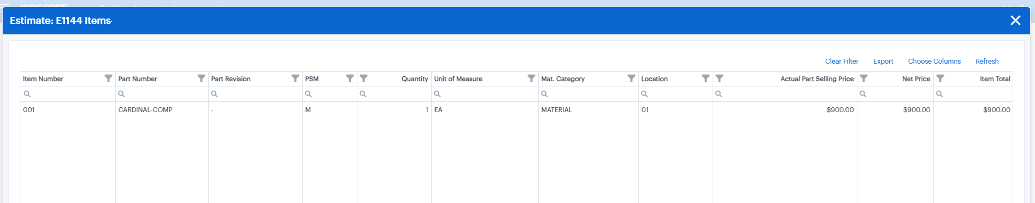

## Widget-Open-Estimates-Chart

This custom item/widget populates a chart that shows the total price of open estimates per sales agent. This is NOT complete. The hopes for this were to create a drill down chart that showed the customers associated with the estimates and sales agent. The columns used to populate this data are the SalesAgent1 and TotalPrice. SalesAgent1 serves as the argument (x-axis) for the bar chart and TotalPrice for the series value (y-axis). Since this custom item is not complete, its current functionality is simple. When hovering over a bar it shows the associated estimate price. This is not functionally exactly how I would like it as you can hover over several parts of a bar, and it will show varying prices. This is because it is not totaling the sum of each estimate per sales agent into one bar but rather several bars stacked on top of each other. This will make more sense when the item is run in the dashboard. I left some more notes on the functionality and the drill down I hoped too but was unable to complete for this item. Please refer to the file to see said comments.

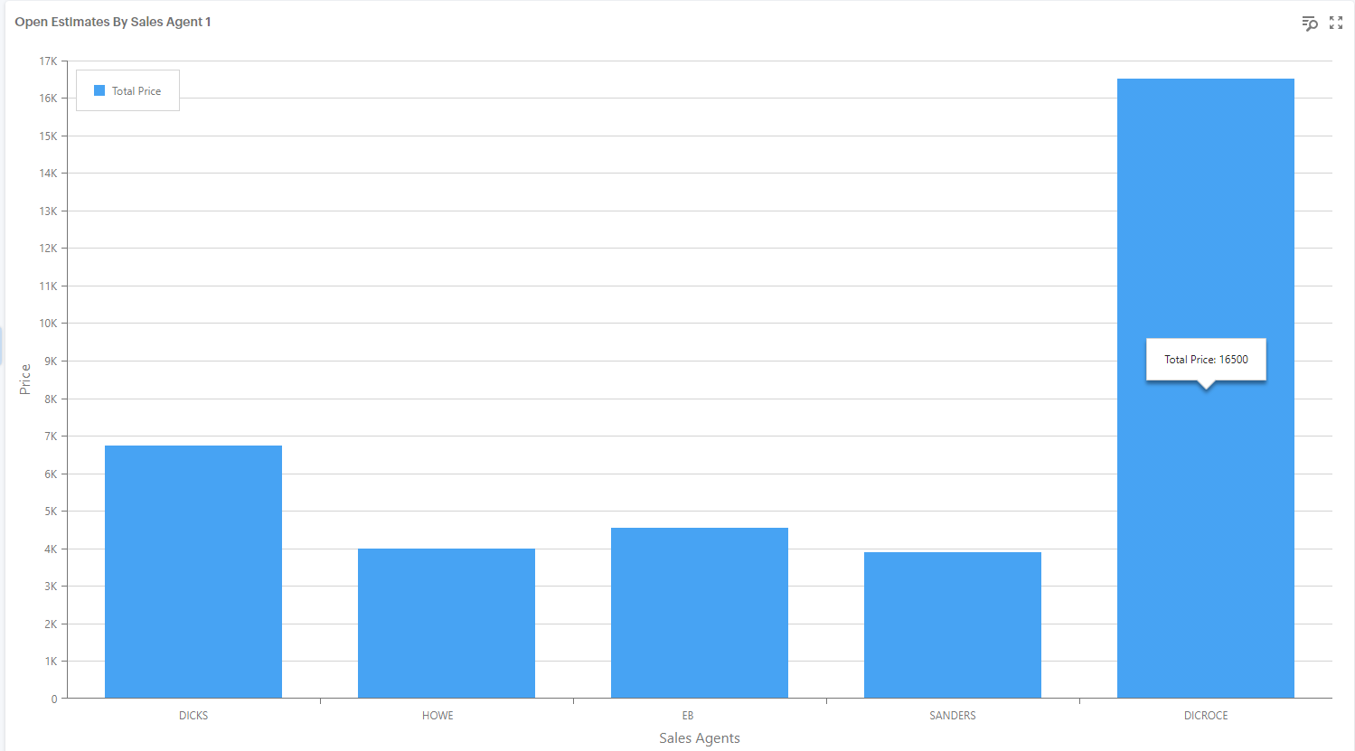

## Pros and Cons of Custom Items/Widgets versus Standard Dashboards

|  |  |
| --- | --- |
| Pros of Custom Items | Cons of Custom items |
| * **Column Chooser**   In custom items there is such thing as a column chooser in the tool bar. This allows for any columns in the JVIEW to be added to/removed from the present grid. Simply dragging and dropping the column into the grid and the data will populate. In the dashboard designer grid, users are not able to drag and drop columns into the grid shown, they would have to go into the dashboard designer and add that said column to the grid they wish to see it on.   * **More Options for Customization**   Although this must be done in the code and not by customers of JEE, creating custom items allows for my customization with coloring, styling, etc. in an item itself. The dashboard designer has limited options for this outside of changing the color scheme of the bar graphs. Since it is hard coded in the item there is a larger variety of ways to style an item in the code.   * **Custom Drill Downs**   In the custom items, you can create drill downs of different types – i.e. you can have a bar chart drill down into a grid. Users can select a button that displays a popup of whatever chart you want. You cannot not drill down into different types of charts, grids, etc. in the dashboard designer. Nor can you have popups over current items on the dashboards in dashboard designer.   * **Data Sources Doesn’t Need to be Connected**   Since custom items are hard coded, they do not need to be connected to a data source through the dashboard designer. All filtering and data selection is done in the code. However, if a dashboard is created and imported by someone else, all filtering and data will connect automatically if that user has those views/tables in their database and nothing will have to be changed. | * **Time and Resources**   Creating custom items for each KPI would be extensive work for developers to partake in. This is because these items must be hard coded using languages such as C# and JavaScript –which only developers are familiar with. Using the dashboard designer though is feasible for anyone in the company who has a clear understanding of the JEE tables and views. In short, training people to create dashboards in the dashboard designer is something that can be done on both development and supports side with less training.   * **Not Interactivity Between Items**   Each custom item is like its own bubble while you can create drill downs and popups within a single custom item, a custom item cannot interact with other features on the dashboard. In the dashboard designer you can place items into groups and tabs and have them interact based on filters however you would like – this is not feasible with a custom item.   * **Creating a Dashboard in Designer Regardless**   Regardless of the fact if you create a custom item, you still must create a dashboard using the custom items. It is not the same in the WinForms version where you could select an item, and it will appear on the dashboard. For a custom item to appear it must be placed into a dashboard through the designer. Essentially going through the process of creating a dashboard using the dashboard designer tools. |

## Steps to Include a Custom Item/Widget in Your Project

1. Move file to JEE/JEE-*BranchHere*/JobscopeWeb/Jobscope.WebCore/wwwroot/ app/src/legacy/js/jobscope/dashboard-items folder
2. Once in folder, it will appear in VS under the same folder structure as above, right click on file and include in project
3. In the jobscope folder above the dashboard-items there is a file called dashboards.js. It is here you need to go in a add your custom item to the list (view files)
4. Inside of the JEE Views you must also enter the name of your custom item to the index.cshtml for Dashboards and DashboardDesigner (view files)